Chemistry and the Scientific method
- Chemistry is the ___________ of the composition of ____________ and the changes it undergoes.
- ________________ is what everything is made of.
- Why study Chemistry?
- You and everything around you are influenced by chemistry:
- The ________________ we eat.
- The________________ we breathe.
- ________________ that we take.
- ________________ we use.
- The world be live in.
The scientific method Chemistry is based on the scientific method!
- Scientific method: a logical approach to the __________________ of scientific ______________
- 1. ______________: using ______________s to obtain information.
- 2. ______________: a proposed ______________ for your observation.
- 3. ______________: a means to______________a hypothesis.
- Scientific method
- 4. A ______________: a broad and extensively______________explanation of why experiments give certain results.
- 5. Scientific ______________: a concise statement that ______________ the results of many observations and experiments.
- *Laws state what ______________, theory's explain ______________ they happen.
- The experiment
- In an experiment only ______________is tested at a time.
- A ______________ is a condition of the experiment that ______________
- A constant or a ______________ is a condition of the experiment that is kept ______________

- The experiment
- Example: A student wants to find out what type of fertilizer will grow the most roses on a rose bush.
- Experiment: 10 rose bushes are split into two groups of 5. All rose bushes are given equal amount of water and light. The first group of roses is given a fertilizer that was bought at a local store. The second group was given no additional fertilizer.
- The experiment
- What is the variable that is being tested in this experiment?
- What is the control group?
- What type of data can be taken from this experiment?
- How long should the student let the experiment go?
- What could the student test next?

Scientific method worksheet
- How does a scientific theory differ from a law?

- Describe two situations in which you used at least part of the scientific method.

- Place the following in order according to the scientific method: theory, hypothesis, observation, experiment.

- If a student has a sore throat and goes to the doctor. The doctor examines the students throat and say that the student has strep throat, a type of bacterial infection. The Dr takes a sample to test for strep bacteria. What parts of the scientific method is the Dr applying?

- On a cold morning your car does not start. You say, “Oh no! The battery is dead!” Your friend who works on cars uses a battery tester and finds that the battery has a full charge. Your friend notices a lot of corrosion on the battery terminals. Your friend says, “Maybe corrosion is causing a bad connection in the electrical circuit, preventing the car from starting.” Your friend cleans the terminals and the car starts.

- Which statements are observations?
- Which statements are hypotheses?
- Which statement describes an experiment?
Mulitiple choice, chose the best answer for the questions below:
6. In order to advance to the level of a theory, a hypothesis should be:
a. obviously accepted by most people.
b. a fully functional experiment.
c. in alignment with past theories.
d. repeatedly confirmed by experimentation.

7. What is the first step of the scientific method?
a. conducting an experiment
b. reaching a conclusion
c. stating a theory
d. formulating a hypothesis
e. making an observation
8. The difference between a scientific theory and a scientific law is that _____ .
a. a law only summarizes observations; a theory attempts to explain observations
b. a theory only summarizes observations; a law attempts to explain observations
c. There is no difference.
9. A hypothesis is _____ .
a. a concise statement that summarizes the results of a wide variety of experiments
b. a descriptive model for observations
c. a thoroughly tested model
d. an observation recorded from an experiment

10. An important characteristic of an accepted scientific theory is that _____ .
a. it can be disproved at any time. c. it cannot be modified.
b. it is agreed upon by all scientists. d. it can be proven true.
The Strange Case of BeriBeri
In 1887 a strange nerve disease attacked the people in the Dutch East Indies. The disease was beriberi. Symptoms of the disease included weakness and loss of appetite, victims often died of heart failure. Scientists thought the disease might be caused by bacteria. They injected chickens with bacteria from the blood of patients with beriberi. The injected chickens became sick. However, so did a group of chickens that were not injected with bacteria.
One of the scientists, Dr. Eijkman, noticed something. Before the experiment, all the chickens had eaten whole-grain rice, but during the experiment, the chickens were fed polished rice. Dr. Eijkman researched this interesting case. he found that polished rice lacked thiamine, a vitamin necessary for good health.
1. State the Problem
2. What was the hypothesis?
3. How was the hypothesis tested?
4. Should the hypothesis be supported or rejected based on the experiment?
5. What should be the new hypothesis?

How Penicillin Was Discovered
In 1928, Sir Alexander Fleming was studying Staphylococcus bacteria growing in culture dishes. He noticed that a mold called Penicillium was also growing in some of the dishes. A clear area existed around the mold because all the bacteria that had grown in this area had died. In the culture dishes without the mold, no clear areas were present.
Fleming hypothesized that the mold must be producing a chemical that killed the bacteria. He decided to isolate this substance and test it to see if it would kill bacteria. Fleming transferred the mold to a nutrient broth solution. This solution contained all the materials the mold needed to grow. After the mold grew, he removed it from the nutruient broth. Fleming then added the nutrient broth in which the mold had grown to a culture of bacteria. He observed that the bacteria died.
6. Identify the problem.
7. What was Fleming's hypothesis?
8. How was the hypothesis tested?
9. Should the hypothesis be supported or rejected based on the experiment?
10. This experiment lead to the development of what major medical advancement?

Analyzing graphs
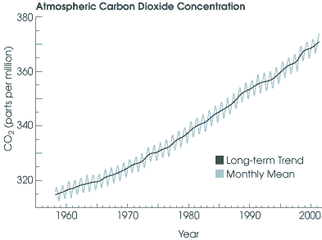
- Based on the above graph, what conclusions can be drawn:
- Water vapor in the atmosphere has increased from 1960 to 2000
- Carbon dioxide is harmful to plant life
- Carbon dioxide in the atmosphere has decreased from 1990 to 2000
- Carbon dioxide has increased in the atmosphere from 1960 to 2000
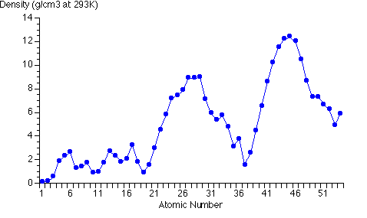
- What is the atomic number of the element with the greatest density?
- 27
- 37
- 44
- 6
- An element has a density of 5 g/cm³. This element is to have an atomic number of :
- 3
- 46
- 26
- 22
- Using the following graph: 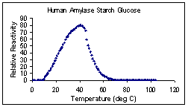

What is the optimum temperature in which human amylase starch glucose operates at:
- 20 ºC b. 40 ºC c. 60 ºC d. 80 ºC

According to the following graph:

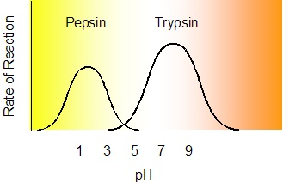

- Which enzyme functions best at a low pH?
- Pepsin b. Trypsin
c. amylase d. both pepsin and trypsin function equally well across the range of pH

- What is the optimal pH for trypsin:
- 1 b. 3 c. 8 d. 12
- What is the optimal pH for pepsin:
- 1 b. 3 c. 8 d. 12
- The rate of reaction for pepsin at a pH of 6 is:
- high b. average c. nearly zero d. equal to the rate of reation for trypsin

