Name ________________________________ Per # _______ Date: _________

Biology – Chapter 11 - Genetics
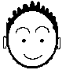Create a Face Dry Lab

Introduction:
Why do people look so different from each other? Even close relatives often look very different from each other. This happens because a very large variety of traits exist in the human population and new variations are created as humans reproduce. Remember during meiosis there can be reshuffling and even crossing over of genes. In this activity, we will learn why brothers and sisters have different genotypes (genetic messages on their DNA) and phenotypes (physical appearances), even when they share the same parents.

So… CONGRATUALTIONS! You are a parent! You and your lab partner represent a couple that will contribute one allele of each trait to your “baby”.

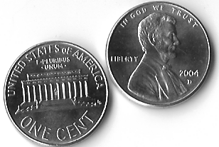Materials:
- A partner
- A penny
- Colored pencils

Procedure:
- Obtain a partner and the rest of your materials. Decide which of you will contribute the genes of the mother and which will contribute the genes of the father.
- Find out the sex of your child:
- Remember your mom’s genotype is XX and dad’s is XY. So only Dad flips the coin.
- Heads represents Y sperm, which means the child will be a boy.
- Tails represents X sperm, which means the child, will be a girl.
- Give your bouncing baby a name.
- Determine the genes that you and your partner have. Look at your face to determine what your genotype may be. You will flip a coin to determine whether you are heterozygous or homozygous dominant.
- Discover the facial features your child will have by using your genotype and that of your partner. If you are heterozygous for that trait, flip a coin to determine which gene will be passed down to your child.
- Draw your child’s Senior Picture. When you have determined all the features of your child’s face, draw and color the way your baby will look when he/she has reached their senior year of high school. Be sure to put in all the facial features described in the lab.
- Complete the analysis section of the lab. Then, attach the lovely drawing of your child to the data sheet and turn it in.
Facial Features
1. Face Shape |  | Round (RR , Rr) |  | Square (rr)
 |  | 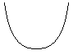 |  | 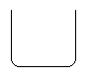
2. Chin Shape |  | Prominent (PP, Pp) |  | Weak (pp)
 |  | 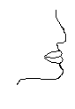 |  | 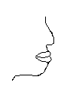
3. Cleft Chin |  | Present (CC, Cc) |  | Absent (cc)
 |  | 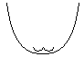 |  | 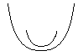
4. Skin Color:
Skin color involves 3 gene pairs. Try your best to determine which of the colors your skin is closest to from the right-hand column.
Each capital letter represents an active gene for melanin production (color). You will need to flip a coin 3 times to determine which of the letters from each pair is passed down to your child. Then add up the # of capital letters from you and your partner and match it to the column on the left to determine the phenotype of the baby.

 |  | 6 capitals  5 capitals  4 capitals  3 capitals  2 capitals  1 capitals  0 capitals | Very dark black skin (DD, DD, DD)  Very dark brown (Dd, DD, DD)  Dark brown (Dd, Dd, DD)  Medium brown (Dd, Dd, Dd)  Light brown (Dd, Dd, dd)  Light tan (Dd, dd, dd)  White (dd, dd, dd)  d

5. Hair Color:
 | Like skin color, hair color is produced by several genes (polygenic or multiple alleles). For the purpose of this activity we will assume that 4 pairs are involved (more are likely As before, the capital letters (dominant) represent color while the lower case (recessive) represent little or no color. Flip a coin 4 times to determine which of the genes from each pair will be passed down to your child.
 |  | 8 capitals  7 capitals  6 capitals  5 capitals  4 capitals  3 capitals  2 capitals  1 capitals  0 capitals | Black (BB, BB, BB, BB)  Very dark brown (Bb, BB, BB, BB)  Dark brown (Bb, Bb, BB, BB)  Brown (Bb, Bb, Bb, BB)  Light brown (Bb, Bb, Bb, Bb)  Honey blond (Bb, Bb, Bb, bb)  Blond (Bb, Bb, bb, bb)  Very light blond (Bb, bb, bb, bb)  White (bb,bb,bb,bb)
6. Red Hair Color
 | Red hair seems to be caused by a single gene with two alleles:
 |  | Dark red (RR) |  |  | Light red (Rr) |  |  | No red (rr)
 | Red hair is further complicated by the fact that brown hair will mask or hide red hair color. The lighter the hair color the more the red can show through. If your child has 3 or less capitals (for hair color, see number 5), and RR is tossed your child will have flaming red hair. (Have fun with your colored pencils!) If your child inherited 3 or more capitals, you don’t need to change the hair color, it will be in the brown tones and the red color is hidden.
7. Hair Type: incomplete dominance
 | Curly (CC) |  |  | Wavy (Cc) |  |  | Straight (cc)
 | 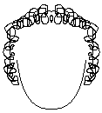 |  |  | 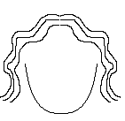 |  |  | 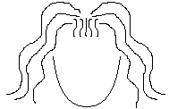

8. Widow’s Peak: The hair comes to a point…like Eddie Munster
 |  | Present (WW, Ww) |  |  | Absent (ww)
 |  | 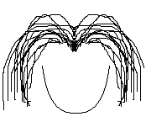 |  |  | 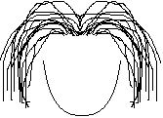
9. Eyebrow Thickness: |  |  | Bushy (BB, Bb) |  | Fine (bb)
 |  | 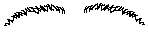 |  |  | 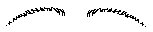
10. Eye Color:
 | Assume that there are two gene pairs involved, the capital letters represent more color and the lower case, less color. Dark eyes are dominant over light. Assume that there are two layers of color on the iris of the eye. The first alleles (A or a) code for the front of the iris and the second alleles (B or b) code for the back of the iris. Determine the first layer, A, then the second layer, B. In reality eye color is much more complex than this. Again, flip a coin 2 times to determine which members of each allele pair get passed down to your child (one A and one B).
 |  | AABB  AABb  AaBB  AaBb  Aabb  aaBB  aaBb  aabb |  | Dark brown  Dark brown  Brown with green flakes  Hazel  Dark blue  Green  Grey blue  Light blue
11. Eyelashes: |  | Long (LL, Ll) |  |  |  | Short (ll)
 |  | 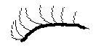 |  |  |  | 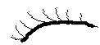

12. Mouth Size:
 | Long (LL) | Average (Ll) |  | Short (ll)
 | 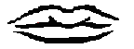 | 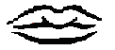 |  | 
13. Lip Thickness: | Thick (TT, Tt) |  | Thin (tt)
 | 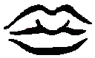 |  | 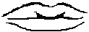
14. Dimples:
 | Present (PP, Pp) |  | Absent (pp)
 | 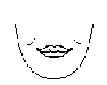 |  | 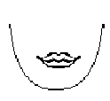
15. Nose Size:
 | Big (BB) | Average (Bb) |  | Small (bb)
 | 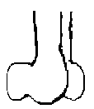
16. Nose Shape: | Rounded (RR, Rr) |  | Pointed (rr)
 |  |  | 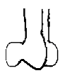
17. Earlobe Attachment:
 | Free (FF, Ff) |  | Attached (ff)
 | 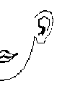 |  | 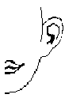
18. Freckles on Cheeks:
 | Present (PP, Pp) |  | Absent (pp)
 | 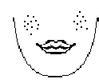 |  | 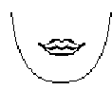
19. Freckles on Forehead:
 | Present (PP, Pp) |  | Absent (pp)
 | 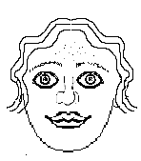 |  | 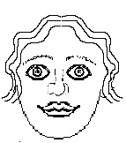

Parent Names: |  | Baby’s Name:

Create A Face Lab Data Sheet
Facial Trait | Genes from Mother |  | Genes from Father | Baby’s Genotype |  | Baby’s Phenotype
1. Face Shape
2. Chin Shape
3. Cleft Chin
4. Skin Color
5. Hair Color
6. Red Hair
7. Hair Type
8. Widow’s Peak
9. Eyebrow Thickness
10. Eye Color
11. Eyelashes
12. Mouth Size
13. Lip Thickness
14. Dimples
15. Nose Size
16. Nose Shape
17. Earlobe Attachment
18. Freckles on Cheeks
19. Freckles on Forehead

Analysis:
The traits in this activity were created to illustrate how human heredity works in a simple model. In real life, the heritance of facial features is much more complex and is determined by the way several sets of genes work together.

- How much does each parent contribute to a child’s genetic make-up?

- What does the coin flip represent?

Define the following terms IN YOUR OWN WORDS:

- Genotype:

- Phenotype:

- Dominance:

- Recessive:

- Incomplete Dominance:
STAPLE YOUR CHILD’S PICTURE TO THE FRONT

