Biology Unit 6 Calendar – Ch. 10: Cell Division & Ch. 11-4 Meiosis

November 7, 2013 – November 22 2013

Monday | Tuesday | Wednesday | Thursday | Friday
4  Study Guide for Ch. 9 | 5 (Sub)  Ch. 9 test | 6  Myth Busters Movie | 7  10-1 Notes  10-1 Section Review- Due Friday! | 8  TED-Ed Video and notes/discussion
11  NO SCHOOL  Veterans Day | 12  Mitosis Poster  10-2 Section Review Due Thursday! | 13  Complete and present Posters | 14  Mitosis Lab | 15  Ch. 10 review  Mitosis Lab Due!
18  Ch. 10 Quiz  Start Meiosis – Vocab and figure 11-15 | 19  TED-Ed Video and notes/discussion | 20  11-4 section review – Due Tomorrow! | 21  Chapter 11-4 Review | 22  Ch. 11 Quiz  Unit 6 Packet Due!

**All work not complete in class becomes homework. Homework can also be assigned randomly- does not have to be indicated on this calendar.

** Read Chapter 10, sections 1-2 and Chapter 11 section 4 to keep up with class discussions and assignments.

Participation Packet Grading Rubric:

Unit calendar and Rubric ________/5 Points
Unit Notes ________/ 8 Points (2 points per page)
Daily Pages ________/ ________ Points (5 points per page)
Graphic Organizer ________/ 10 Points
Unit Study Guide ________/ ________ Points (1 point each)
Vocabulary (Ch. 10-11) ________/ 17 Points
Total Points _________/________ Points
Cell Division
Ch. 10 Notes

When a living thing grows, what happens to its cells?

Living things grow by producing more ___________; the cells of adults are _________________________ than those of a young person (just ___________ of them)

Limits to Cell Growth:

Two reasons why cells divide instead of continue to grow:

a) The larger a cell becomes, the more demands the cell places on its ______________

b) The more trouble the cell has moving enough nutrients and wastes across the __________________________________________

DNA Overload:

______________ stores the information that controls a cell’s __________________.

When a cell is small, the DNA is able to meet all the cells needs

As a cell increases in size, it _______________________ make extra copies of ____________________.

If cells continued to grow without limit = “__________________________________________”

Why A Small Cell Functions Better Than a Larger Cell

Think of a library in a small town…
And the town has been constantly growing, but the library was not able to add more books?

If a cell continued to grow the amount of DNA it contained would not be enough to _______________________________________________________________________________________________

Moving Materials

Food, Oxygen, Water & Waste enter/leave a cell through the _________________________.

a) The rate at which moving materials takes place depends on the ________________________ of the cell (total area of cell membrane)

b) The way the materials are used in the cell depends on its _______________________

Ratio of surface area to volume:

Volume increases much more rapidly than _____________________________________ = the ratio of surface area to volume ___________________________.

This causes problems with the movement of _________________________.

Maintaining volume to surface area is key for processes of the cell to happen quickly and efficiently, and for ___________________________ movement of ___________________

Division of the cell:

Before a cell gets WAY TOO big, it will _________________________ and form 2 “_________________________” CELLS

This process is called _______________________________________.

Cell Division:

Before a cell divides:
a) It ____________________________________ (copies) all of its DNA
b) Each “daughter” cell gets a complete set of _____________________________

Why it Divides:
a) Division keeps the ________________ to ___________________________________ ratio appropriate
b) And allows for optimal ________________________ of molecules in, out and within!

WHAT DO YOU KNOW NOW?!?!?!

Answer the following in complete these sentences, below the prompt/question in the space provided!!

1.Cells divide because ____(2 reasons)______.

2.It is not ideal for cells to increase in size because __________________.

3.(Pick one) Volume or Surface area increase more rapidly.

4.Just before division the cell must ____________ because ______________.
The Cell Cycle:10-2

During the cell cycle:
a) The cell grows
b) Prepares for division
c) Divides to form 2 daughter cells

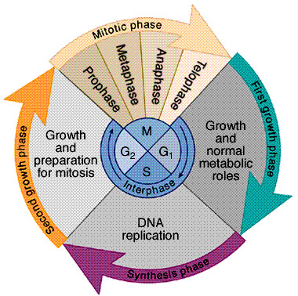

Phases of the Cell Cycle

1. ______ Phase – Growth
2. ______ Phase – DNA Replication
3. ______ Phase – Prep for mitosis
a) G1, S, and G2 phases are ______________________________
4. ______ Phase – Cell Division (Mitosis)

Three reasons why cells reproduce:
1.
2.
3.

